DEPRECIATION
Introduction, straight line method of depreciation, declining balance method of depreciation – Sum of the year’s digits method of depreciation, sinking fund method of depreciation / Annuity method of depreciation, service output method
INTRODUCTION
Any equipment which is purchased today will not work forever. This may be due to wear and tear of the equipment or obsolescence of technology. Hence, it is to be replaced at the proper time for continuance of any business. The replacement of the equipment at the end of its life involves money. This must be internally generated from the earnings of the equipment. The recovery of money from the earnings of an equipment for its replacement purpose is called depreciation fund since we make an assumption that the value of the equipment decreases with the passage of time. Thus, the word “depreciation” means decrease in value of any physical asset with the passage of time.
Straight Line Method of Depreciation
In this method of depreciation, a fixed sum is charged as the depreciation amount throughout the lifetime of an asset such that the accumulated sum at the end of the life of the asset is exactly equal to the purchase value of the asset. Here, we make an important assumption that inflation is absent.
Let
P = first cost of the asset,
F = salvage value of the asset,
n = life of the asset,
Bt = book value of the asset at the end of the period t,
Dt = depreciation amount for the period t.
The formulae for depreciation and book value are as follows:

Dt = (P – F)/n
Bt = Bt–1 – Dt = P – t [(P – F)/n]

EXAMPLE -01 A company has purchased an equipment whose first cost is
Rs. 1,00,000 with an estimated life of eight years. The estimated salvage value
of the equipment at the end of its lifetime is Rs. 20,000. Determine the
depreciation charge and book value at the end of various years using the straight
line method of depreciation.
Solution
P = Rs. 1,00,000
F = Rs. 20,000
n = 8 years
Dt = (P – F)/n
= (1,00,000 – 20,000)/8
= Rs. 10,000
EXAMPLE 02- Consider the above Example 01 and compute the depreciation and the
book value for period 5.
P = Rs. 1,00,000
F = Rs. 20,000
n = 8 years
D5 = (P – F)/n
= (1,00,000 – 20,000)/8
= Rs. 10,000 (This is independent of the time period.)
B_{t} = P – t (P – F)/n
B₅ = 1,00,000 – 5 (1,00,000 – 20,000)/8
= Rs. 50,000

Q2. A company installs a power generator for ₹8,00,000. The generator has an estimated useful life of 12 years and a salvage value of ₹80,000. Calculate the annual depreciation using the Straight Line Method(60000). Find the book value at the end of 6 years(4,40,000).
Q3. A hotel purchases furniture worth ₹3,00,000. The estimated life of the furniture is 15 years, and its scrap value at the end of its useful life is ₹30,000. Determine the annual depreciation using the Straight Line Method(18000). Compute the book value at the end of 10 years(120000).

Declining Balance Method of Depreciation
In this method of depreciation, a constant percentage of the book value of the
previous period of the asset will be charged as the depreciation amount for the
current period. This approach is a more realistic approach, since the depreciation
charge decreases with the life of the asset which matches with the earning
potential of the asset. The book value at the end of the life of the asset may not
be exactly equal to the salvage value of the asset. This is a major limitation of
this approach.
Let
P = first cost of the asset,
F = salvage value of the asset,
n = life of the asset,
Bt = book value of the asset at the end of the period t,
K = a fixed percentage, and
Dt = depreciation amount at the end of the period t.
The formulae for depreciation and book value are as follows:
Dt = K B_{t-1}
B_{t} = B_{t–1} – D_{t}
= B_{t–1} – K x B_{t–1}
= (1 – K) x B_{t–1}
The formulae for depreciation and book value in terms of P are as follows:
D_{t} = K(1 – K) ^{t–1} x P
B_{t} = (1 – K)^{t} x P

While availing income-tax exemption for the depreciation amount paid in
each year, the rate K is limited to at the most 2/n. If this rate is used, then the
corresponding approach is called the double declining balance method of
depreciation.
EXAMPLE Consider the above Example 01 and demonstrate the calculations of the
declining balance method of depreciation by assuming 0.2 for K.
Solution
P = Rs. 1,00,000
F = Rs. 20,000
n = 8 years
K = 0.2
The calculations pertaining to D_{t} and B_{t} for different values of t are
summarized in Table using the following formulae:
D_{t} = K B_{t–1}
B_{t} = B_{t–1} – D_{t}
Table 9.2 D_{t} and B_{t} according to Declining Balance Method of Depreciation
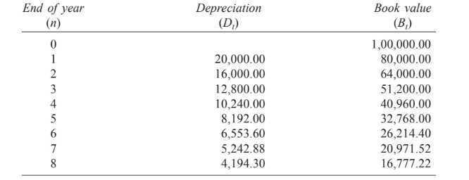
If we are interested in computing Dt and Bt for a specific period t, the
respective formulae can be used.

EXAMPLE Consider Example 01 and calculate the depreciation and the
book value for period 5 using the declining balance method of depreciation by
assuming 0.2 for K.
Solution
P = Rs. 1,00,000
F = Rs. 20,000
n = 8 years
K = 0.2
D_{t} = K(1 – K)^{t –1} x P
D₅ = 0.2(1 – 0.2)⁴ x 1,00,000
= Rs. 8,192
B_{t} = (1 – K)^{t} x P
B₅ = (1 – 0.2)⁵ x 1,00,000
= Rs. 32,768

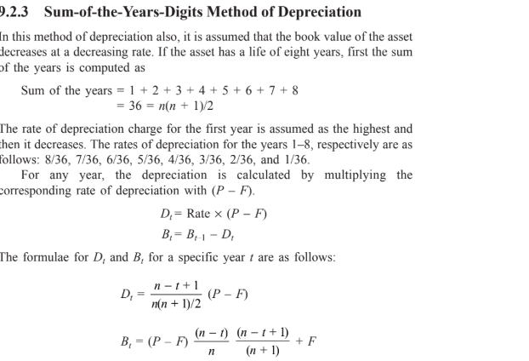
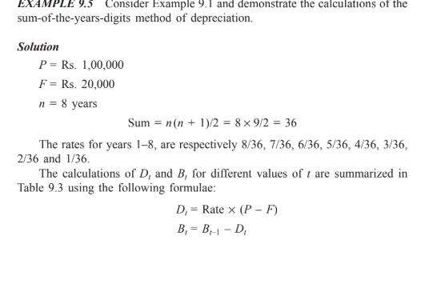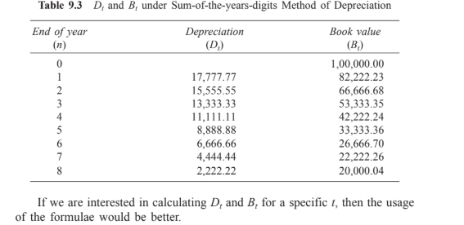
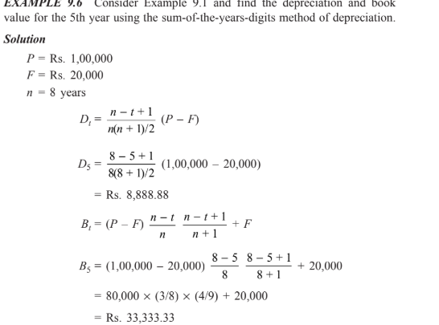

Sinking Fund Method of Depreciation
In this method of depreciation, the book value decreases at increasing rates with
respect to the life of the asset. Let
P = first cost of the asset,
F = salvage value of the asset,
n = life of the asset,
i = rate of return compounded annually,
A = the annual equivalent amount,
B_{t} = the book value of the asset at the end of the period t, and
D_{t} = the depreciation amount at the end of the period t.
The loss in value of the asset (P – F) is made available an the form of
cumulative depreciation amount at the end of the life of the asset by setting up
an equal depreciation amount (A) at the end of each period during the lifetime
of the asset.
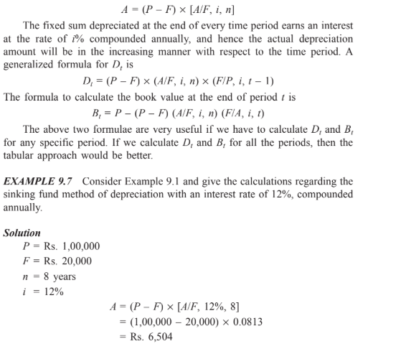
In this method of depreciation, a fixed amount of Rs. 6,504 will be
depreciated at the end of every year from the earning of the asset. The
depreciated amount will earn interest for the remaining period of life of the asset
at an interest rate of 12%, compounded annually. For example, the calculations
of net depreciation for some periods are as follows:
Depreciation at the end of year 1 (D₁) = Rs. 6,504.
Depreciation at the end of year 2 (D₂) = 6,504 + 6,504 x 0.12
= Rs. 7,284.48

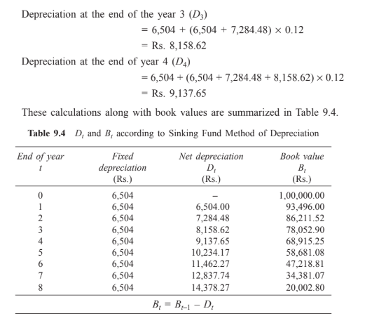

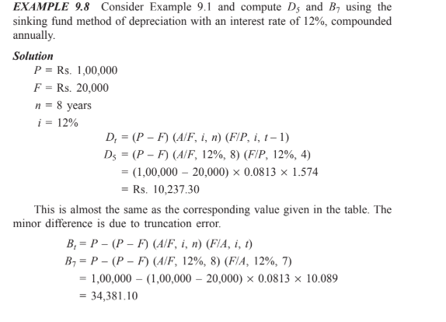

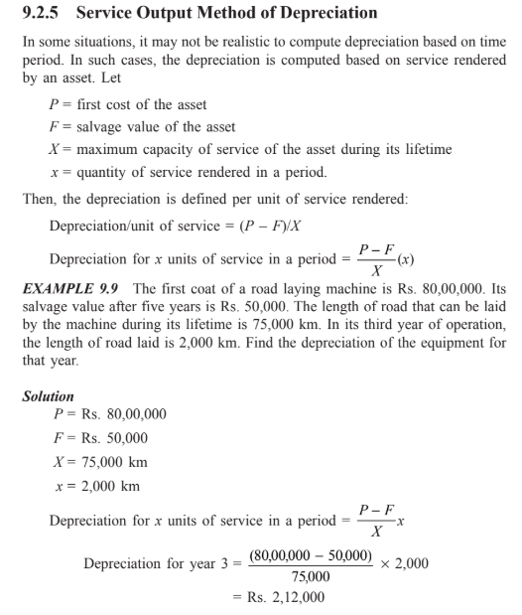

What is depreciation and the difference between straight line method and Declining Balance Method of Depreciation.
Adam Smith:
"Depreciation is the gradual decrease in the value of capital goods over time due to wear and tear, obsolescence, or economic factors affecting its utility."
Or
"Depreciation is the gradual reduction in the value of an asset over time due to wear and tear, obsolescence, or usage."

It is an accounting method used to allocate the cost of a fixed asset over its useful life.
Straight Line Method (SLM):
- Equal Depreciation: Depreciates an asset evenly over its useful life, meaning the same amount of depreciation is recorded each year.
- Calculation: (Cost of Asset - Salvage Value) / Useful Life.
- Suitable for: Assets that depreciate consistently and predictably throughout their lifespan, like buildings or office equipment.
- Simplicity: Easy to calculate and understand.

Declining Balance Method (DBM):
- Accelerated Depreciation:Depreciates an asset faster in the early years and slower in later years, reflecting the assumption that assets lose value more rapidly initially.
- Calculation: Depreciates a fixed percentage of the asset's book value each year.
- Suitable for: Assets that experience a rapid decline in value in the early years, like technology equipment or vehicles.

